SQL – Creating Triggers and Functions

WEEK 9-10

Write the SQL Triggers and functions for the following using Postgres sql.

**1. Create an employee table which contains employee details and the department he works for. Create another table department consisting of dname and number of employees. Write triggers to increment or decrement the number of employees in a department table when the record in the employee table is inserted or deleted respectively.**

**Ans.**

**SQL for funcs and triggers:**

--function to increment emp count on a new hire

create or replace function new_hire_f()

returns trigger as $example_table$

BEGIN

update dept

set count_emp=count_emp+1

where new.dno=dept.dnumber;

return new;

end;

$example_table$ language plpgsql;

--Trigger for new hire

create trigger new_hire

after insert

on emp

for each row

execute procedure new_hire_f();

-- function to decrement count_emp

create or replace function new_fire_f()

returns trigger as $example_table$

BEGIN

update dept

set count_emp=count_emp-1

where old.dno=dept.dnumber;

return old;

end;

$example_table$ language plpgsql;'

--Trigger to deceremnt count once employee entry is deleted

create trigger new_fire

before delete

on emp

for each row

execute procedure new_fire_f();

Creating db, creating tables:







Creating function:

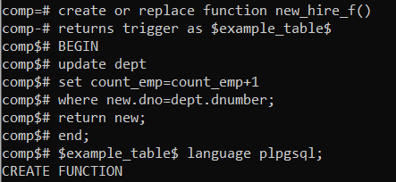

Creating the trigger:

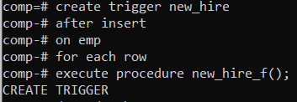

Inserting records into dept table:

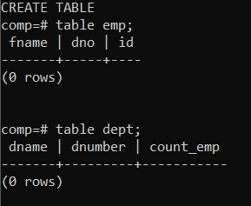 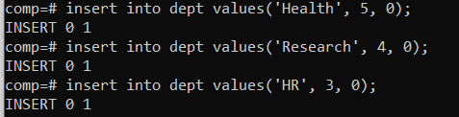

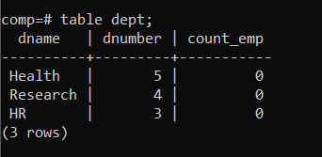

Inserting Values into emp table [increment]:

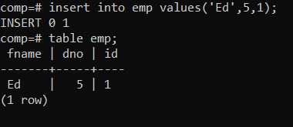 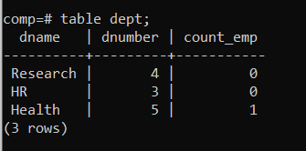

Creating a function for delete:

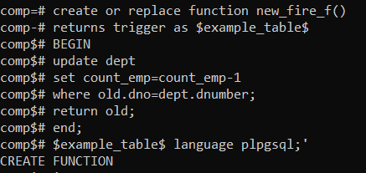

Creating trigger:

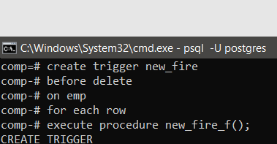

Inserting more records:

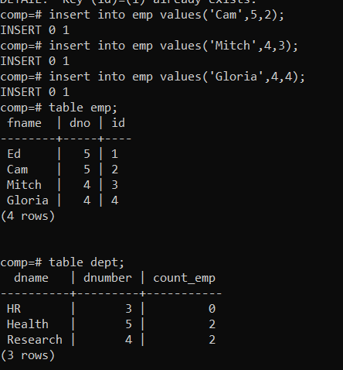

Deleting a record to check if the trigger works:

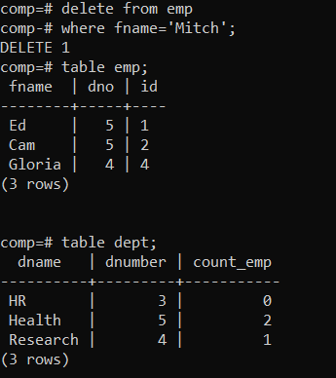

It works!

**2. Create an order_item table which contains details like name, quantity and unit price of every item purchased. Create an order summary table that contains number of items and total price. Create triggers to update entry in order summary whenever an item is inserted or deleted in the order item table.**

Ans:

--Creating function for insert

create or replace function add_item_f()

returns trigger as $example_table$

BEGIN

update order_summary

set tot_price=tot_price+new.qty*new.unit_price,

no_item=no_item+new.qty;

return new;

end;

$example_table$ language plpgsql;

--trigger for insert

create trigger new_item_added

after insert

on order_item

for each row

execute procedure add_item_f();

--function on delete

create or replace function remove_item_f()

returns trigger as $example_table$

BEGIN

update order_summary

set tot_price=tot_price-old.qty*old.unit_price,

no_item=no_item-old.qty;

return old;

end;

$example_table$ language plpgsql;

--trigger on delete

create trigger item_removed

before delete

on order_item

for each row

execute procedure remove_item_f();

--creating function on update

create or replace function update_qty_f()

returns trigger as $example_table$

BEGIN

update order_summary

set tot_price=tot_price+((new.qty-old.qty)*old.unit_price),

no_item=no_item-old.qty+new.qty;

return new;

end;

$example_table$ language plpgsql;

-- Creating Trigger on update

create trigger qty_changed

after update

on order_item

for each row

execute procedure remove_item_f();

creating db and tables:

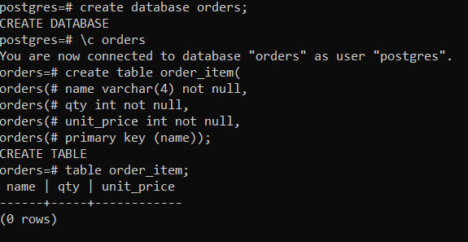

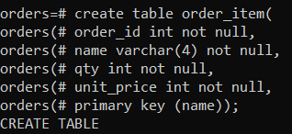

Creating function for insert:

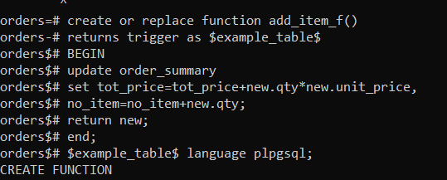

Create trigger for insert:

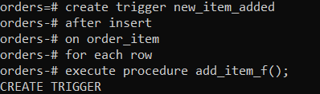

Insert trigger in action:

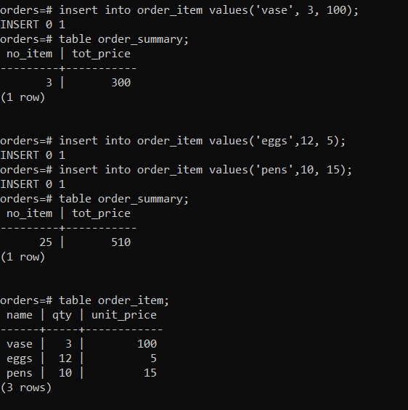

Creating function and trigger for delete:

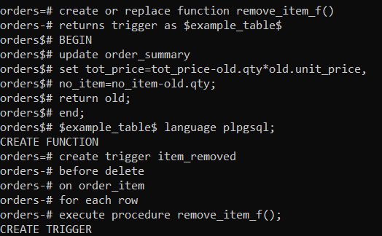

Delete trigger in action:

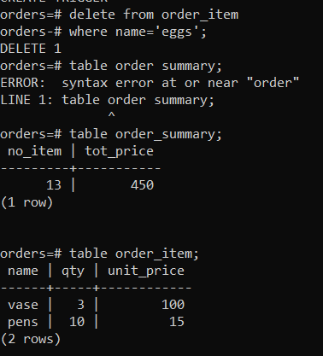

Creating a function and trigger for update:

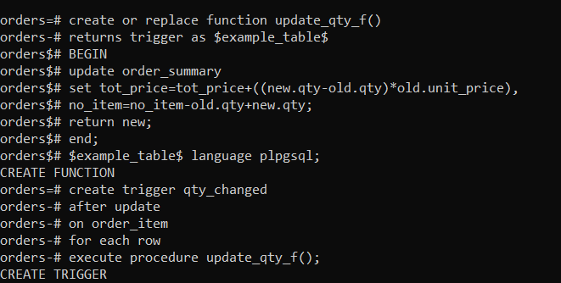

Update trigger in action:

